University of Sarajevo
Faculty of Electrical Engineering (ETF)
Study Program: Data Science and AI (DSAI)
Course: Introduction to Artificial Intelligence
Professor: Prof. Dr. Izudin Džafić

Project Documentation: ConnectXO

A Strategic Game Suite with Adaptive AI and Persistent State Management

Authors: Kanita Tafro (20011) and Džana Kopić (20165)
Date: February 2026

Original sketches vs Implemented flow

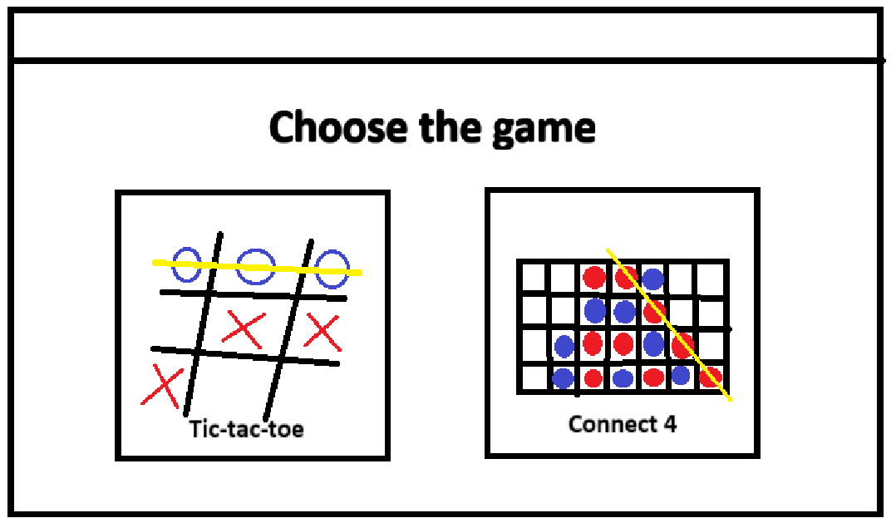
Planned flow: Start view -> game view (Connect 4/Tic tac toe) -> “Quit the game?” pop-up after game is done (win/loss/draw detected)
- Start view (“Choose the game” view) has 2 buttons that lead to the view of the chosen game. Settings view exists only in Start view.
- Tic-tac-toe view: playing field (3x3 grid) where new tokens can appear in any blank cell
- Connect 4 view: playing field (6x7 grid) where new tokens can appear in the first from the bottom blank cell of the wanted column (populating the grid from the bottom)

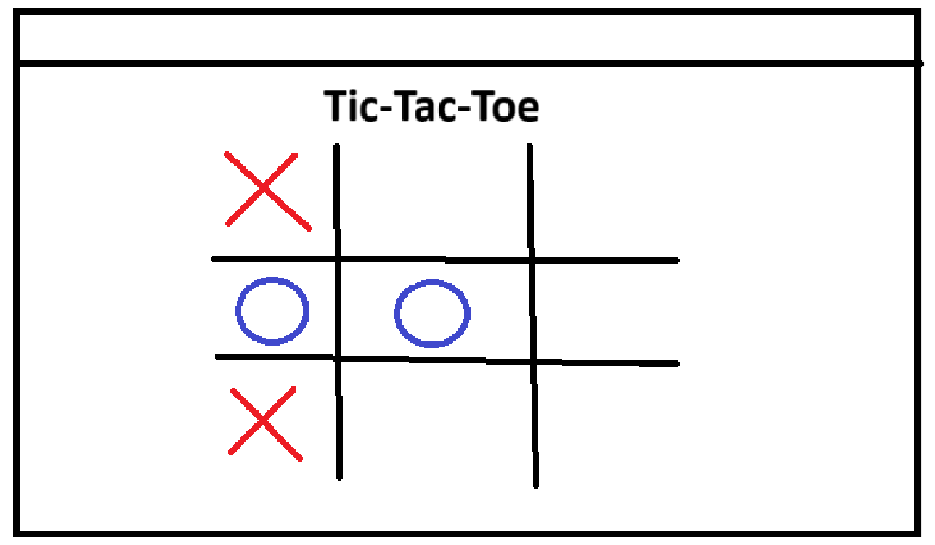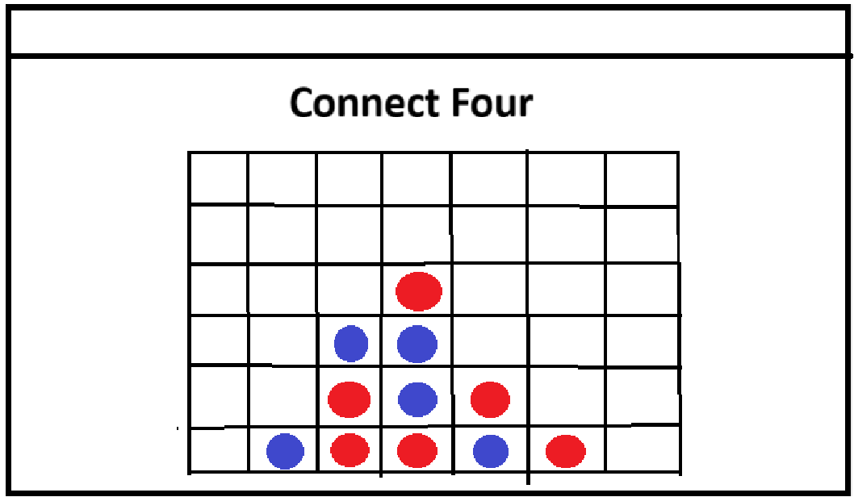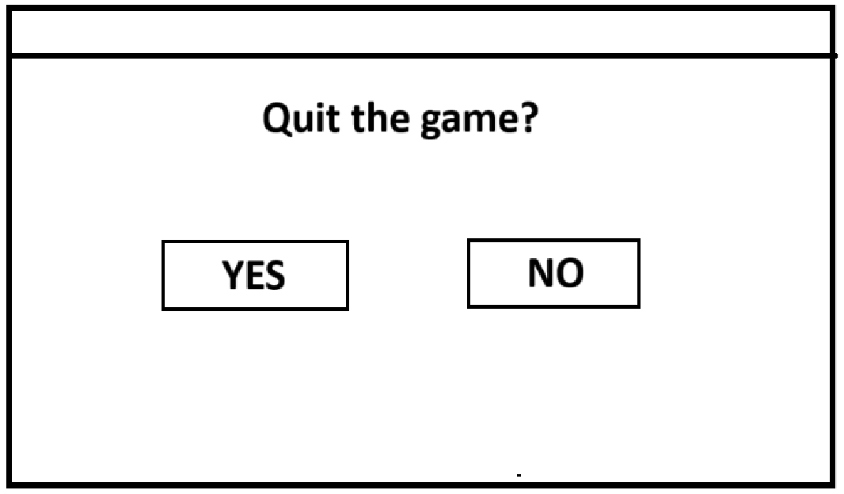
Implemented flow: Start view -> game view -> options to quit (exit the game view) or replay (rematch option in which the wins/losses counters keep going)
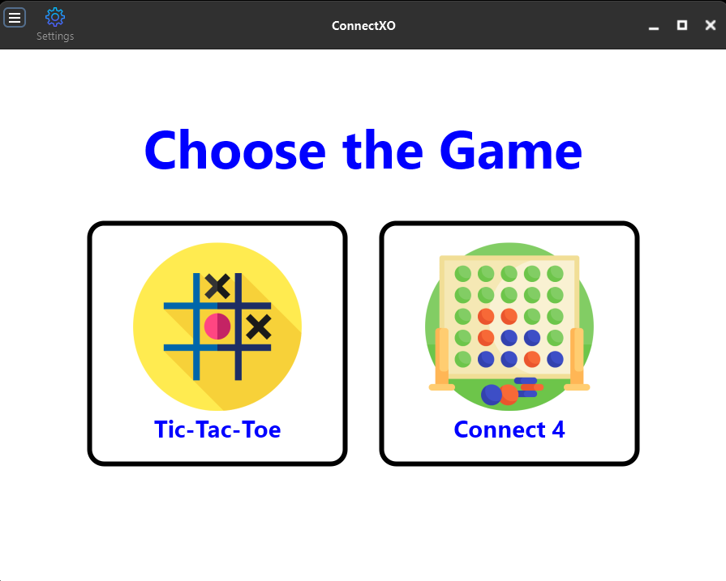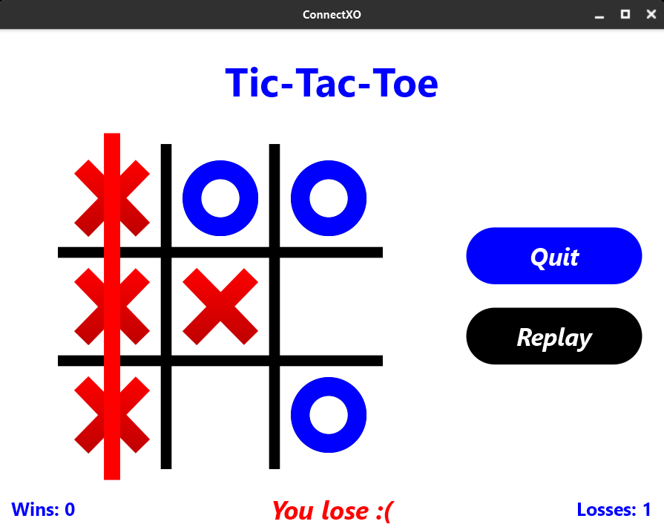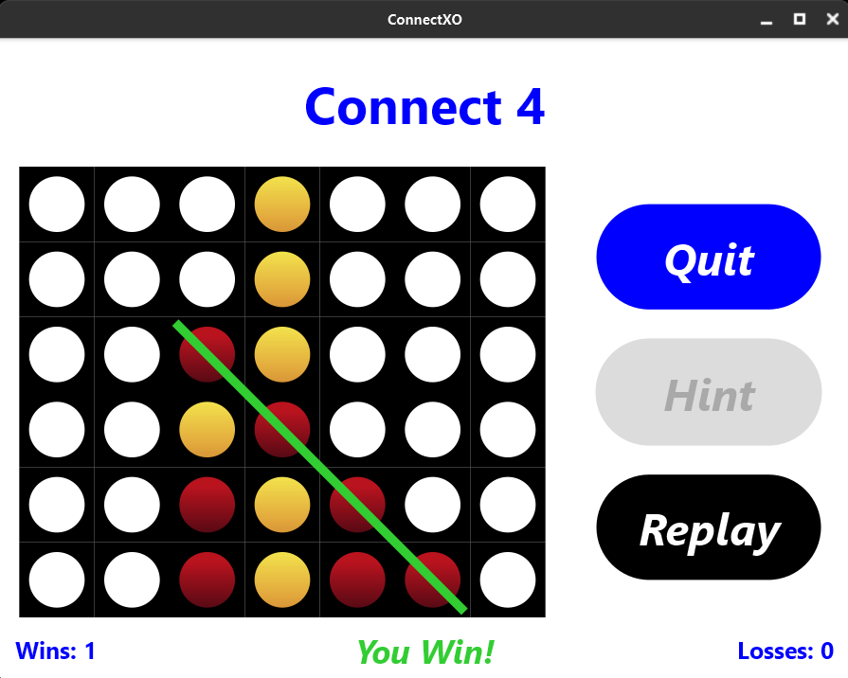

2. Algorithm & AI Architecture

The AI Engine
We implemented the Minimax algorithm with Alpha-Beta pruning. This optimization allows the AI to ignore branches in the search tree that cannot possibly affect the final decision, significantly improving performance and allowing for deeper lookahead.

Difficulty Modes
The AI intelligence is scaled by adjusting the search depth of the Minimax algorithm across five tiers:
- Very Easy: 30% search depth
- Easy: 45% search depth
- Medium: 65% search depth
- Hard: 80% search depth
- Very Hard: 100% search depth (Maximum strategic strength)

AIPlayer Logic (.h and .cpp)
The implementation follows a clean Object-Oriented structure:
- Player Enum: Defines the turns and ownership of moves.
- Game Abstract Base Class: Acts as a blueprint for both Tic-Tac-Toe and Connect 4. This allows the AI to remain "game-agnostic"—it doesn't care which game it is playing; it just evaluates the board state provided by this interface.
- AIPlayer Class: The core controller that executes the Minimax logic and returns the optimal move.

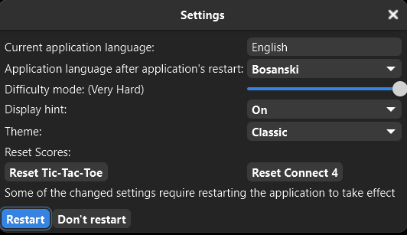
3. User Experience
- 3 languages: English, Bosnian, Spanish
- 5 color themes (4 light, 1 dark theme)
- replay button with wins/losses counters that keep counting the user wins and losses
- the counters remember the score until “reset” buttons in settings are pressed (2 separate buttons for each game)
- hint button (and the option to turn hints on/off in settings) that helps the user by highlighting the next optimal move
- animations:
  - hover animation (when hovering the mouse over the playing field, the game token appears at 75% size)
  - token drop animation in Connect 4 when making a move with dropping sound
- winning line after 3-in-a-row (Tic-tac-toe) or 4-in-a-row (Connect 4) is detected
  - red-ish color when user loses (AI wins)
  - green/navy color when user wins (AI loses)
- declaration of win/loss/draw as overlay in the footer

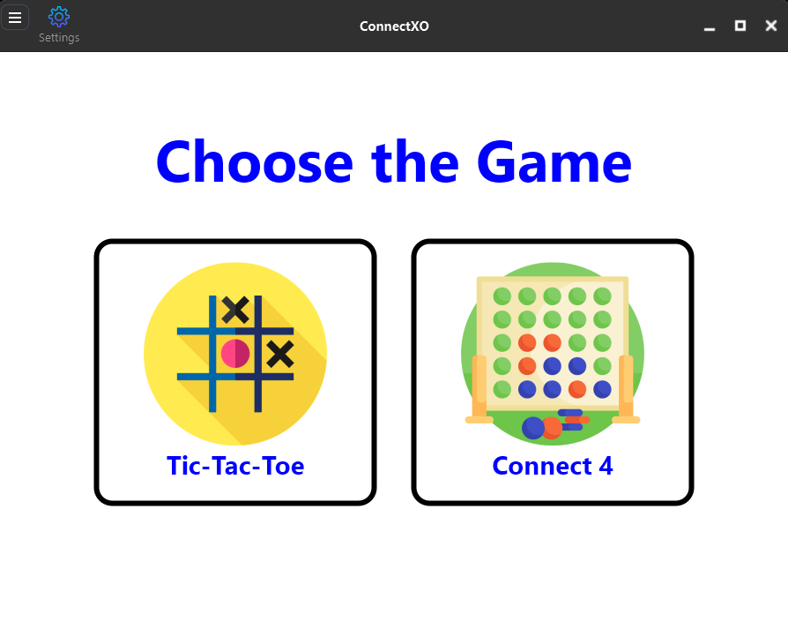
4. Color Themes

Classic
bgColor = td::ColorID::White;
accentColor = td::ColorID::Blue;
secondaryColor = td::ColorID::Black;
gridColor = td::ColorID::Black;
winLine = td::ColorID::LimeGreen;
loseLine = td::ColorID::Red;

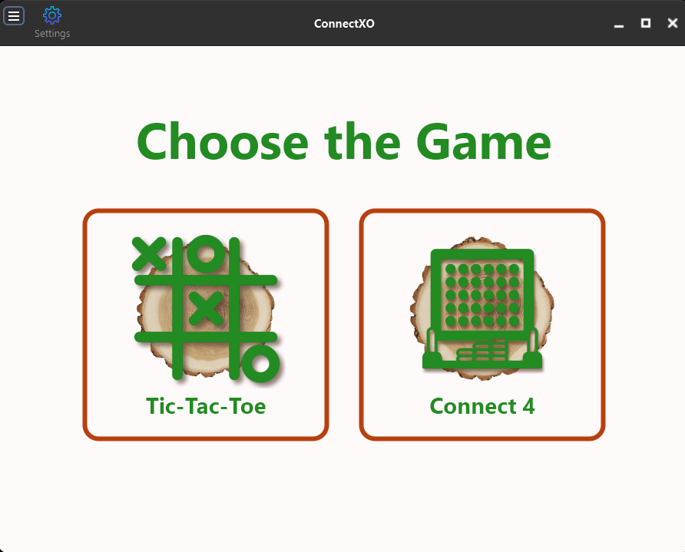
Nature

bgColor = td::ColorID::Snow;
accentColor = td::ColorID::ForestGreen;
secondaryColor = td::ColorID::Rust;
gridColor = td::ColorID::Tan;
winLine = td::ColorID::Lime;
loseLine = td::ColorID::Red;

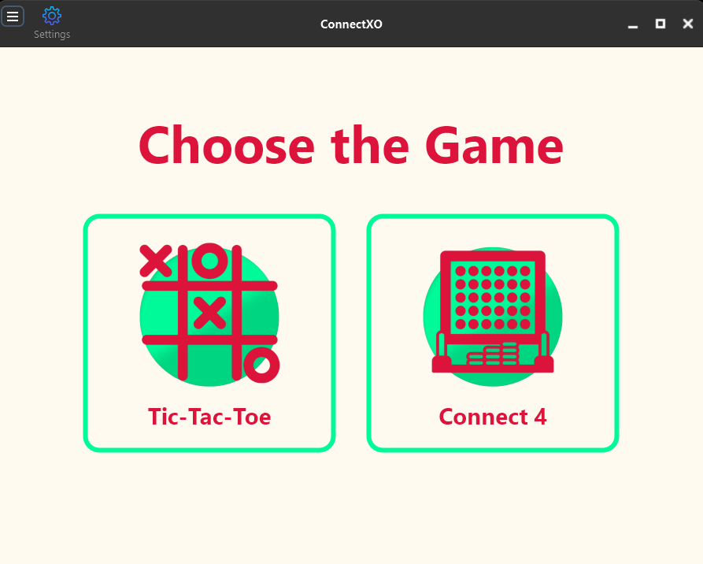
Strawberry

bgColor = td::ColorID::FloralWhite;
accentColor = td::ColorID::Crimson;
secondaryColor = td::ColorID::MediumSpringGreen;
gridColor = td::ColorID::Salmon;
winLine = td::ColorID::ForestGreen;
loseLine = td::ColorID::Red;

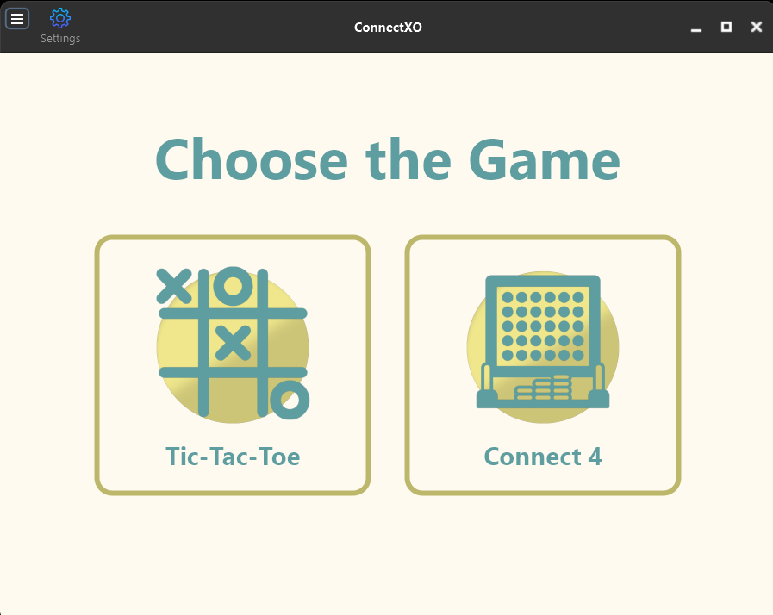
Beachy

bgColor = td::ColorID::SeaShell;
accentColor = td::ColorID::CadetBlue;
secondaryColor = td::ColorID::DarkKhaki;
gridColor = td::ColorID::Gray;
winLine = td::ColorID::Navy;
loseLine = td::ColorID::DarkSalmon;

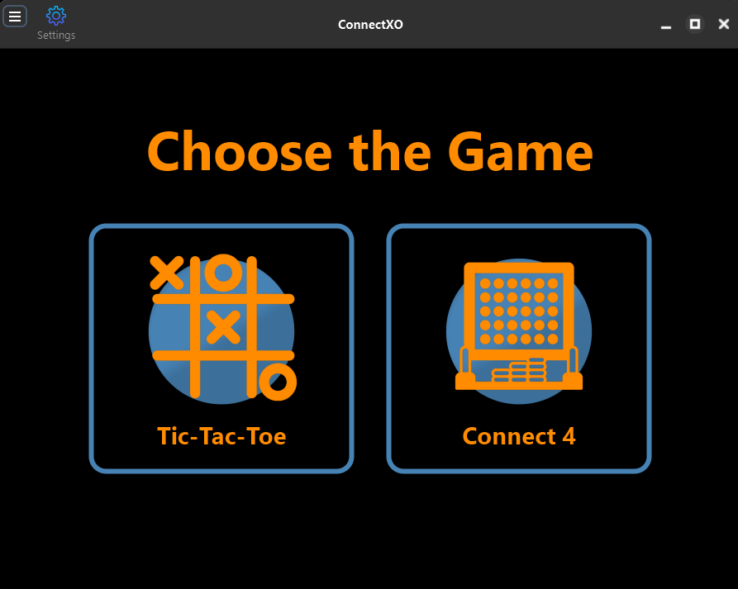
Dark

bgColor = td::ColorID::Black;
accentColor = td::ColorID::DarkOrange;
secondaryColor = td::ColorID::SteelBlue;
gridColor = td::ColorID::ObsidianGray;
winLine = td::ColorID::LimeGreen;
loseLine = td::ColorID::Red;

